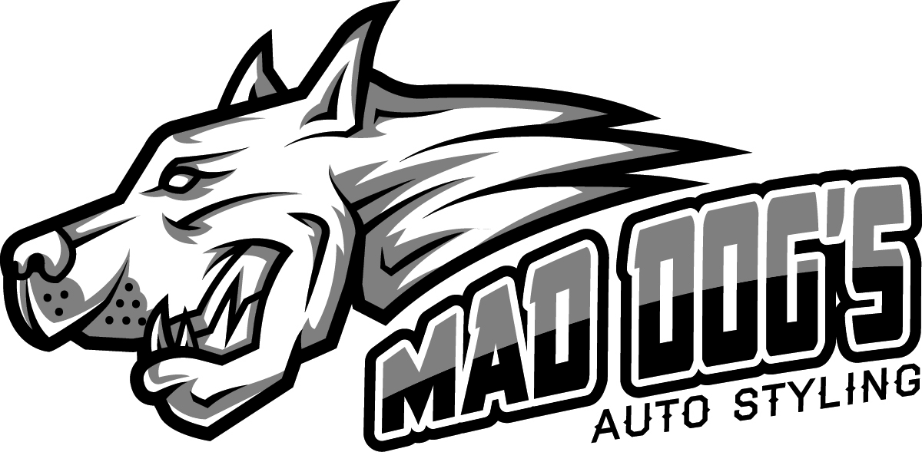

**Wrap Maintenance Sheet**

Keeping the vehicle clean is the No. 1 thing you can do right. Removing dirt build up and road grime will keep the protective laminate from getting stained and dull. The maintenance tips on our sheet all deal with the proper way to keep the wrap clean. While you are doing your cleaning & maintenance, should you see any bubbles or lifting edges, contact us immediately and we will fix the issue before it becomes a bigger problem. **Be sure not to wash your vehicle for 48 hours after install!**

**Q: Can I Take My Wrap Through the Car Wash?**

A: Yes, but only touchless/nonabrasive automatic car washes. Your vehicle is an investment and to protect that investment to the best of your ability, hand washing is always recommended at least every two weeks. Here’s a few tips for making sure that your hand washing protects the vehicle wrap as well:

* Use a non-abrasive cleaner without strong solvents.
* Use plenty of water and wash the vehicle from the top down.
* Avoid brushes—both automatic and hand brushes—as they can cause scratches and dull the finish of the protective laminate. Brushes can also lift loose edges.
* Use a soft sponge or rag and avoid excessive scrubbing.
* Take extra care on matte or textured finishes.
* Rinse any residue thoroughly with clean water.
* Air dry or dry with a microfiber cloth.

**Q: Can I Pressure Wash My Vehicle?**

A: While it’s ok to pressure wash a wrapped vehicle, be sure to follow these guidelines if you do so:

* Avoid excessive pressure which can damage the graphics. (Max. water pressure should be 800 psi to 2000 psi).
* Keep the water temperature at a maximum of 72 to 180 degrees.
* Do not spray damaged graphics as the water can get under the graphic, causing lifting and curling.
* Keep the nozzle at least 12 to 18 inches away from the graphics.
* Do not direct the spray at a sharp angle to the graphics. (Spray angle: 45 degrees)
* Avoid spraying directly on wrap seams.
* Never use a Turbo pressure nozzle.

**Q: Can I Wax My Vehicle?**

A: Vehicle wraps have a protective overlaminate that already enhances the finish of the graphics while providing protection against abrasion and UV damage so an extra polish is not required, but the right polish may help enhance the graphics over time. Here are some tips on what to avoid.

* Avoid Carnauba-based waxes, which require rigorous buffing to bring out a high shine. This buffing can damage the graphics.
* Carnauba-based waxes are also heat sensitive and can melt in the sun creating a greasy mess that attracts dirt and can cause black streaks.
* The heat also releases the stain in the wax which can in turn stain the graphics.
* Teflon or silicone-based polishes are fine but should be specifically designed for use on vehicle wraps.
* Scratches are more obvious and harder to repair on matte and textured finishes and waxes or polishes should be avoided all together.

**Q: What Other Tips Will Help Protect My Wrap?**

A: There are some simple on-going maintenance tips that will help your wrap last. If you should see any bubbles or lifting graphics, be sure to bring the vehicle back in for a professional repair.

* Remove any residue or gunk build-up as soon as possible to avoid damage or staining.
* Test any cleaners you use in an inconspicuous place first.
* Gas spill—wash off residue with soapy water ASAP.
* Oil, tar or asphalt build-up—wipe down with isopropyl alcohol and a citrus-based cleaner.
* Follow any chemical cleanings with a regular washing with water and a mild cleanser.
* To protect against UV damage, try to park in a garage or shaded area as much as possible. A ceramic coating can be applied on the wrap to protect against UV rays for years to come. Ask us about our ceramic packages.

